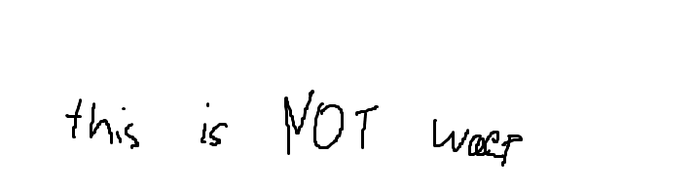 

Semester One Examination, 2024

Question/Answer booklet

MATHEMATICS  
SPECIALIST  
UNIT 3 Year 12

If required by your examination administrator, please place your student identification label in this box

Section One:  
Calculator-free

|  |  |  |  |  |  |  |  |  |  |  |
| --- | --- | --- | --- | --- | --- | --- | --- | --- | --- | --- |
| WA student number: In figures |  |  |  |  |  |  |  |  |  |  |

In words

Your name

|  |  |
| --- | --- |
| Number of additional answer booklets used (if applicable): |  |

## Time allowed for this section

Reading time before commencing work: five minutes

Working time: fifty minutes

## Materials required/recommended for this section

***To be provided by the supervisor***

This Question/Answer booklet

Formula sheet

***To be provided by the candidate***

Standard items: pens (blue/black preferred), pencils (including coloured), sharpener,  
correction fluid/tape, eraser, ruler, highlighters

Special items: nil

## Important note to candidates

No other items may be taken into the examination room. It is **your** responsibility to ensure that you do not have any unauthorised material. If you have any unauthorised material with you, hand it to the supervisor **before** reading any further.

## Structure of this paper

|  |  |  |  |  |  |
| --- | --- | --- | --- | --- | --- |
| Section | Number of questions available | Number of questions to be answered | Working time (minutes) | Marks available | Percentage of examination |
| Section One: Calculator-free | 8 | 8 | 50 | 97 | 35 |
| Section Two: Calculator-assumed | 13 | 13 | 100 | 158 | 65 |
|  | | |  | **Total** | 100 |

|  |  |  |
| --- | --- | --- |
| Markers use only | | |
| Question | Maximum | Mark |
| 1 | 17 |  |
| 2 | 5 |  |
| 3 | 13 |  |
| 4 | 11 |  |
| 5 | 8 |  |
| 6 | 12 |  |
| 7 | 9 |  |
| 8 | 25 |  |
| S1 Total | 97 |  |
| S1 Wt (×0.7) | 35% |  |
| S2 Wt | 65% |  |
| Total | 100% |  |

## Instructions to candidates

1. The rules for the conduct of examinations are detailed in the school handbook. Sitting this examination implies that you agree to abide by these rules.

2. Write your answers in this Question/Answer booklet preferably using a blue/black pen.  
Do not use erasable or gel pens.

3. You must be careful to confine your answers to the specific question asked and to follow any instructions that are specific to a particular question.

4. Show all your working clearly. Your working should be in sufficient detail to allow your answers to be checked readily and for marks to be awarded for reasoning. Incorrect answers given without supporting reasoning cannot be allocated any marks. For any question or part question worth more than two marks, valid working or justification is required to receive full marks. If you repeat any question, ensure that you cancel the answer you do not wish to have marked.

5. It is recommended that you do not use pencil, except in diagrams.

6. Supplementary pages for planning/continuing your answers to questions are provided at the end of this Question/Answer booklet. If you use these pages to continue an answer, indicate at the original answer where the answer is continued, i.e. give the page number.

7. The Formula sheet is not to be handed in with your Question/Answer booklet.

Section One: Calculator-free 35% (97 Marks)

This section has**six** questions. Answer **all** questions. Write your answers in the spaces provided.

Working time: 50 minutes.

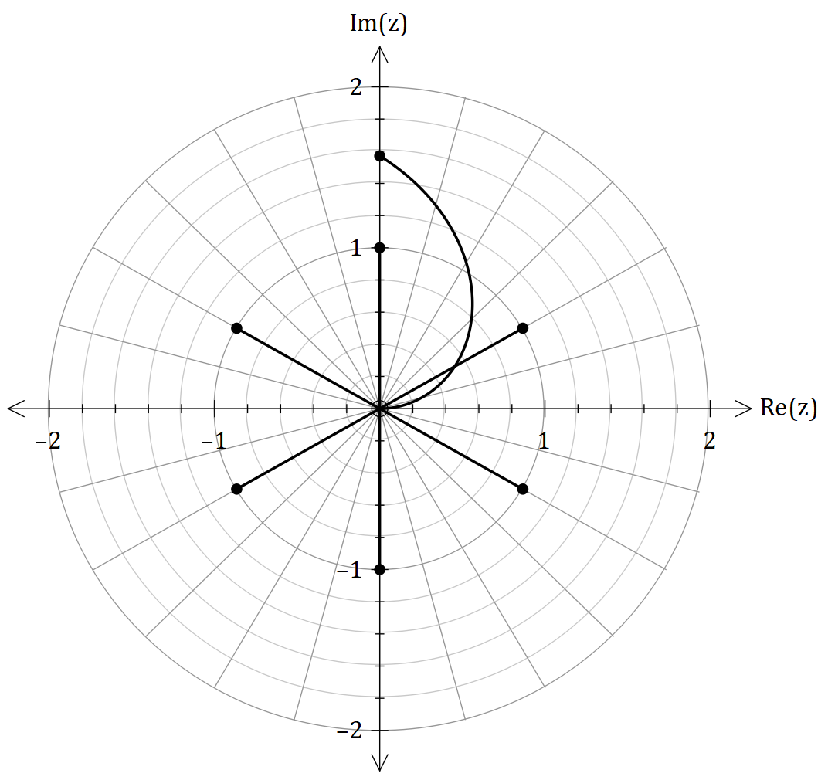

Question 1 (17 marks) ((15

The graph shown to the right shows the  
complex points and ,  
along with a complex function

1. Show the given expression is true.  
   (2 marks) ((
2. From your answer in a), interpret what these coordinates represent. (2 marks)
3. Find the equation for . Hence, what is the polar coordinate of the intersection of and . (2 marks)

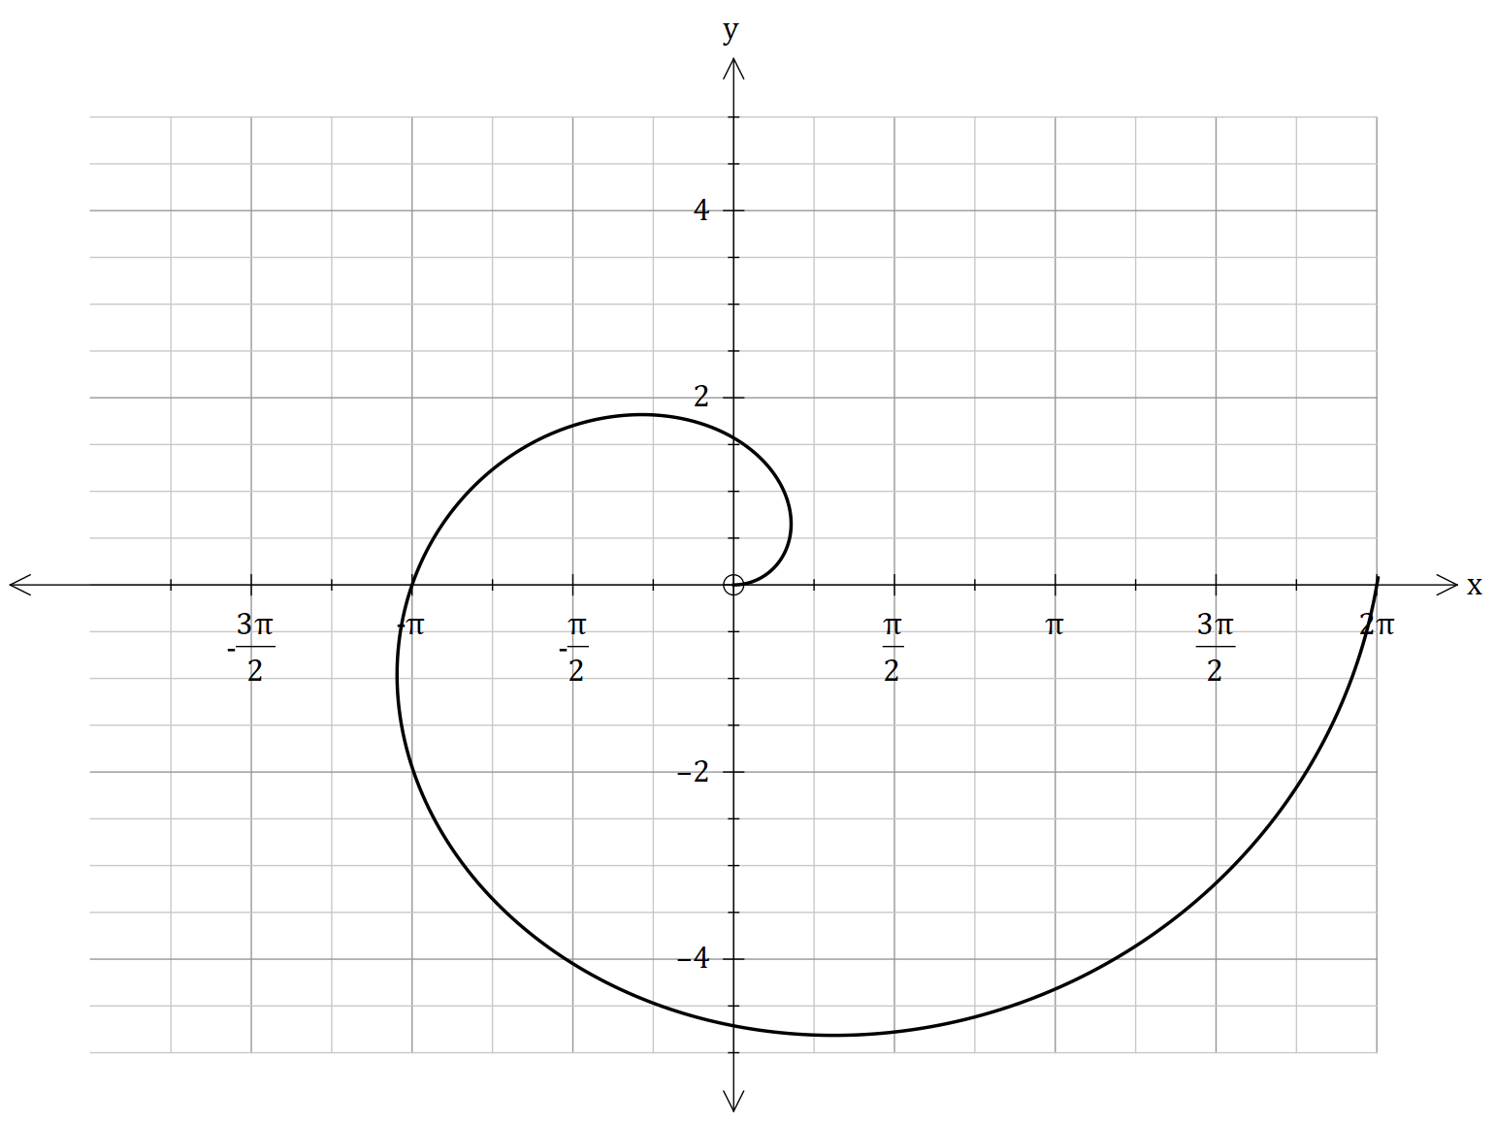Consider now that the equation of is now plotted on the x-y plane.

The Cartesian equation for another body  
is labelled as metres. It’s shown below.

1. Show that the Cartesian equation  
   is given as follows. Hence, plot the  
   graph. (6 marks)
2. Evaluate whether and will collide or intersect from your answer in d) (2 marks)

Question 2 (5 marks)

An acidic reaction took place in a beaker which involves the reaction of hydrochloric acid (HCl2(aq)) and ammonia gas (NH2(g)) and produces a salt. For them to collide, they must have sufficient energy and correct orientation.

At 6:00 PM, this reaction took place, and the position and velocity vectors of the compounds labelled as H and N, is listed below, and they are relative to the point , which is the center of the beaker.

Prove that the reactants collide and determine the time at when they collide.

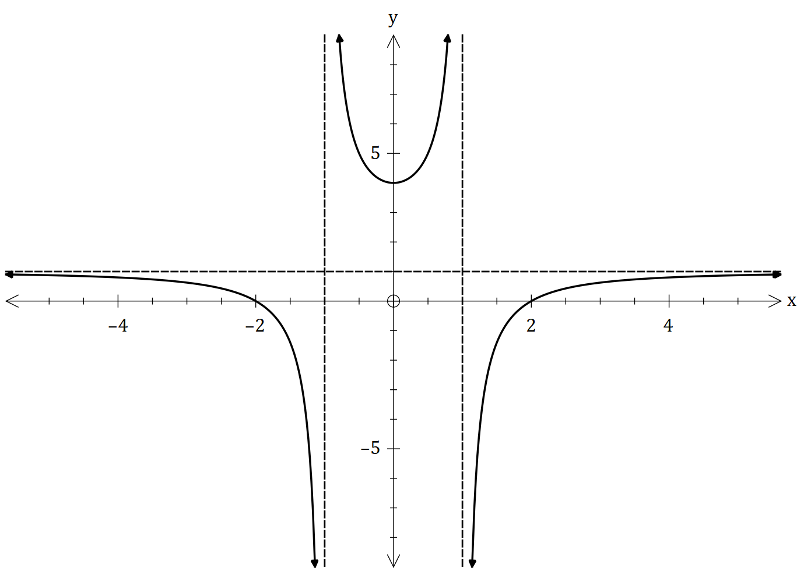Question 3 (13 marks)

The function is defined as .

The sketch of is given in the accompanying  
diagram.

1. Find the values of constants and   
   where , and . (4 marks)
2. Hence, sketch the graph and (3 marks)

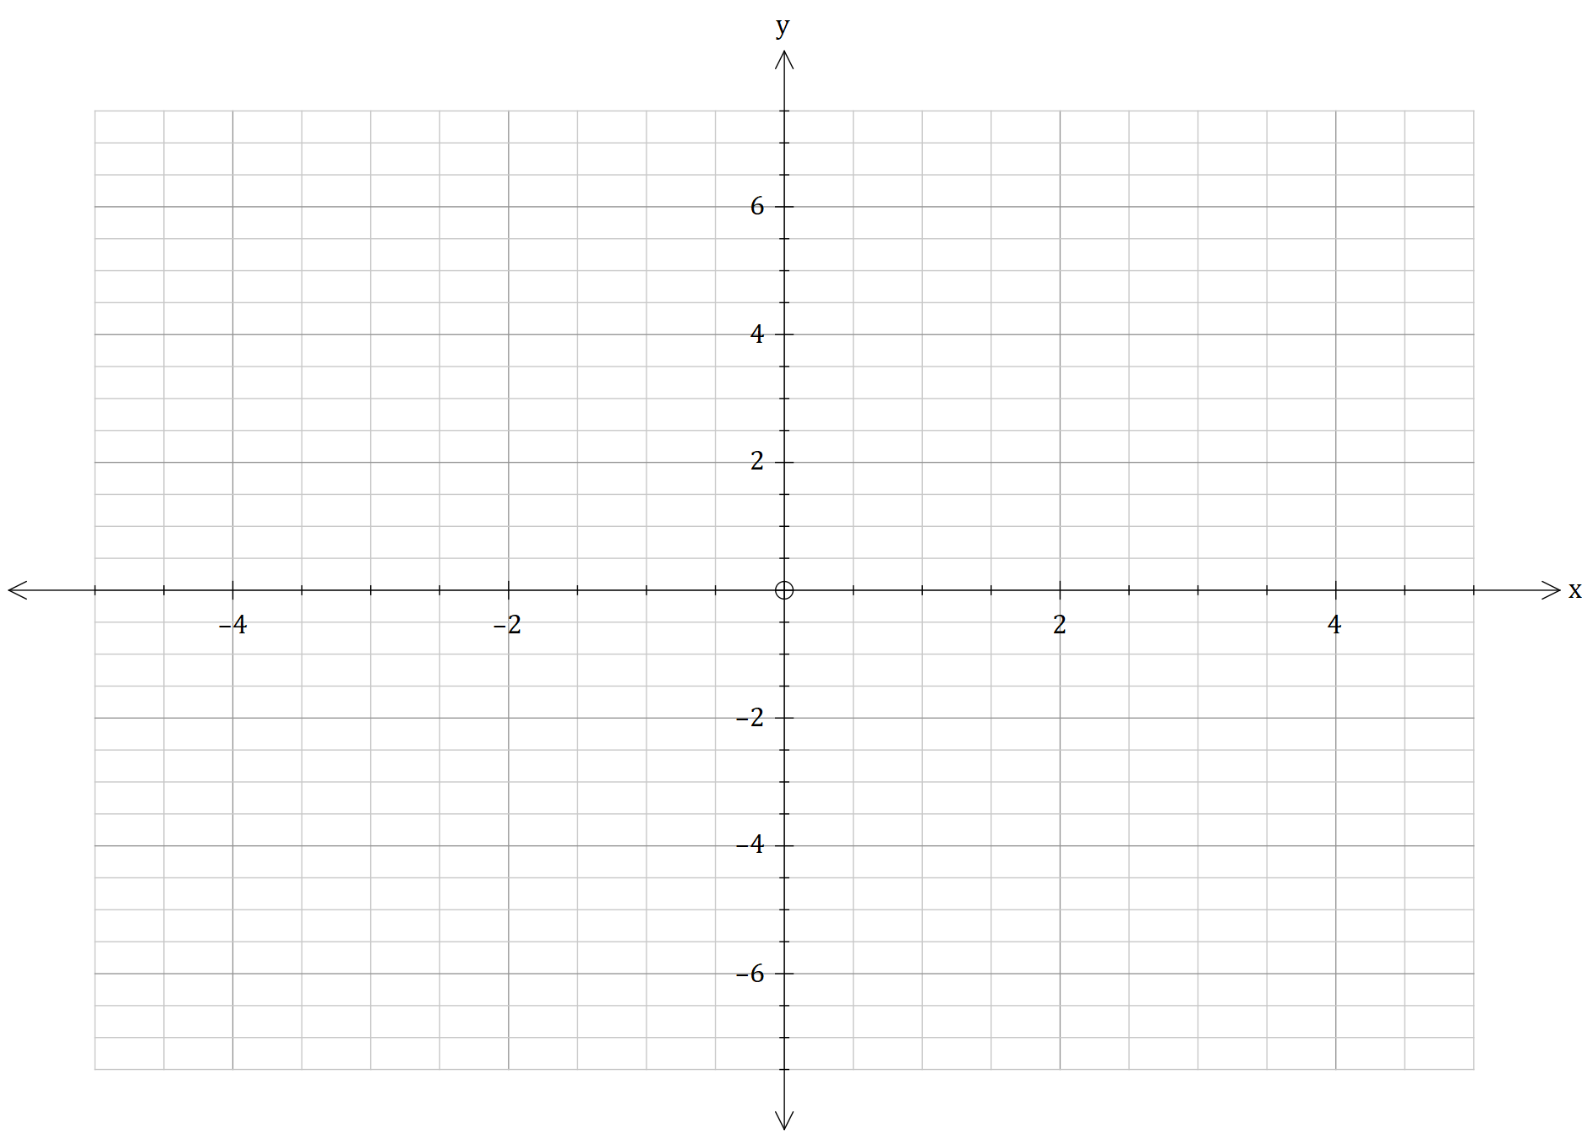

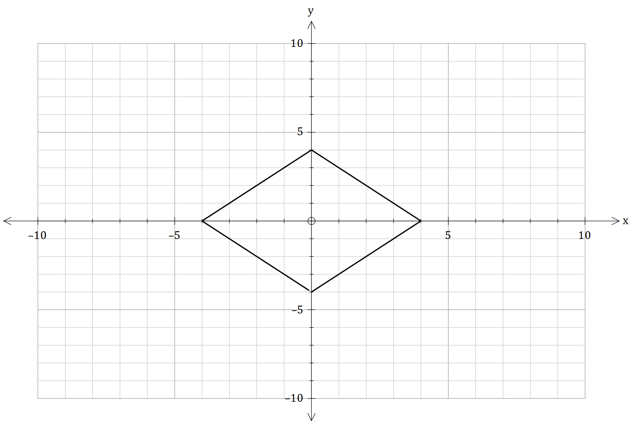The graph below shows the relation .

1. Explain that all the equations don’t have an inverse function. (2 marks)

The function is defined for and for the equation , and is defined for for the equation

1. Hence, find the natural domain of and explain if the natural range is undefined or not. (4 marks)

Question 4 (11 marks)

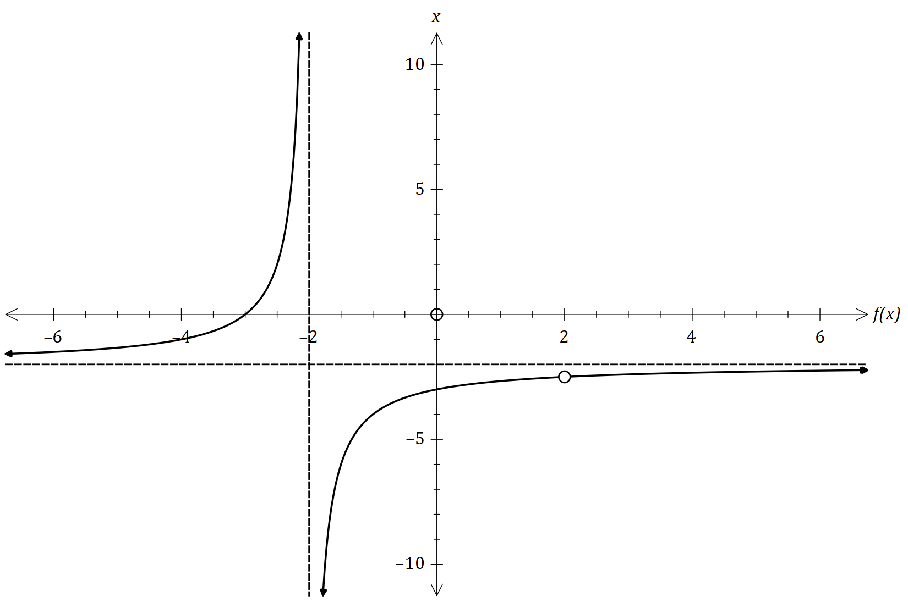

1. For the graph shown to right shows  
   the function . Sketch the function  
   the function . (3 marks)
2. Find the shortest distance between the line and the point with position vector . (3 marks)

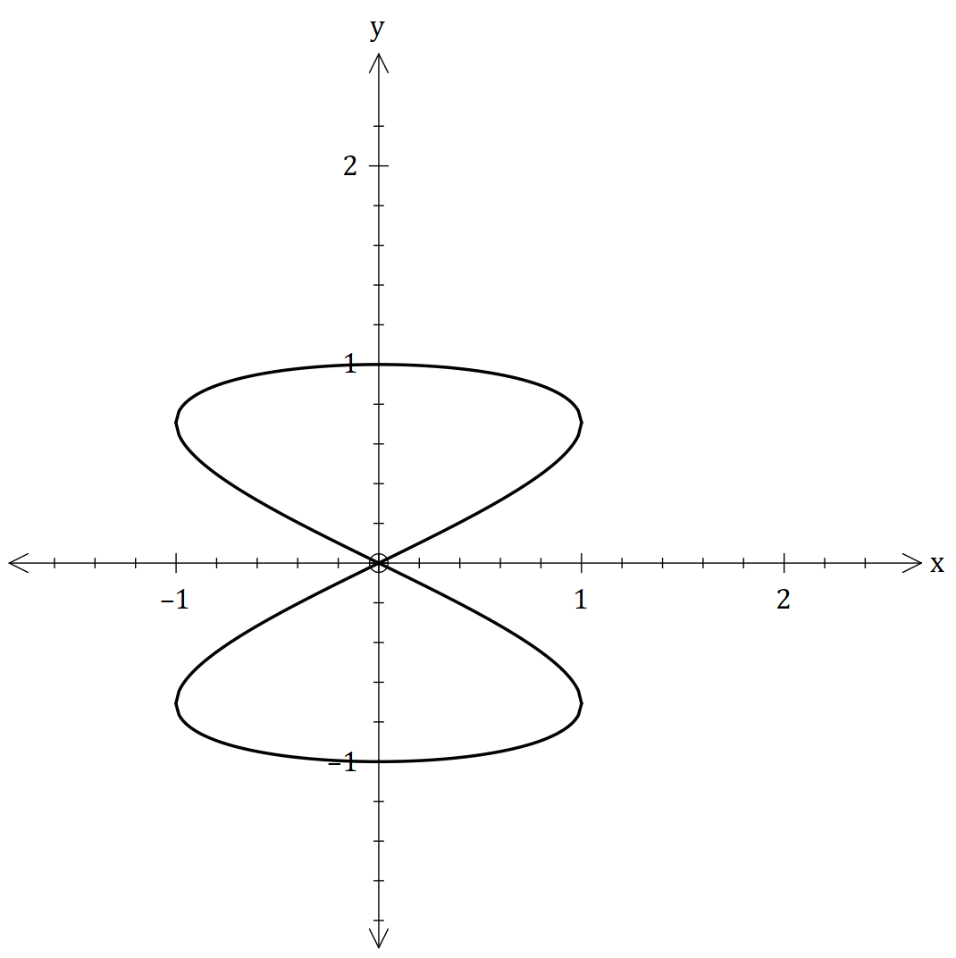

1. The graph shows the position vector of an object  
   at time seconds. The velocity of the object ms-1  
   is given as follows below. (5 marks)  
     
     
     
   If at , is the first time the velocity and   
   acceleration is perpendicular to each-other,   
   find the value of the constant .  
     
   Hence, plot , and to the graph.

Question 5 (8 marks)

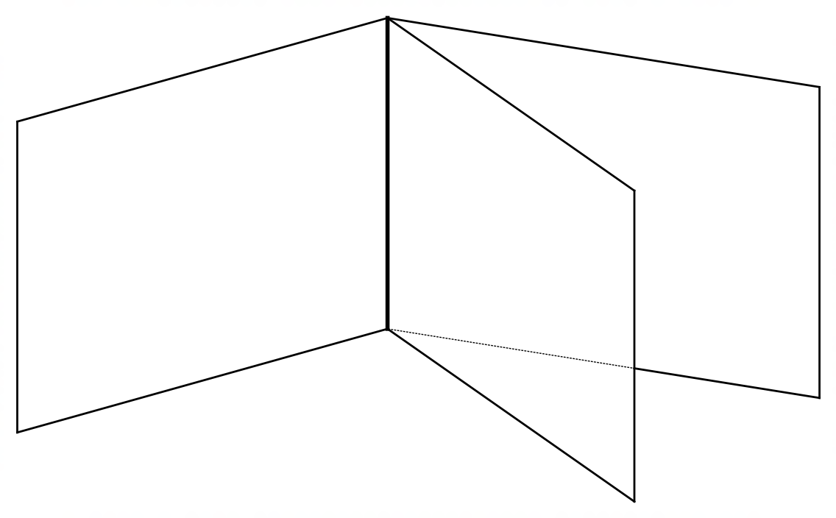

The diagram to the right shows three planes with  
the given system of linear equations.

1. Show by using row-reduction, that the system of linear equations shows relevance to the diagram above. Explain your answer geometrically. (4 marks)

As the planes intersect in a common line, this line can be defined as a vector equation. This is represented by the diagram below.

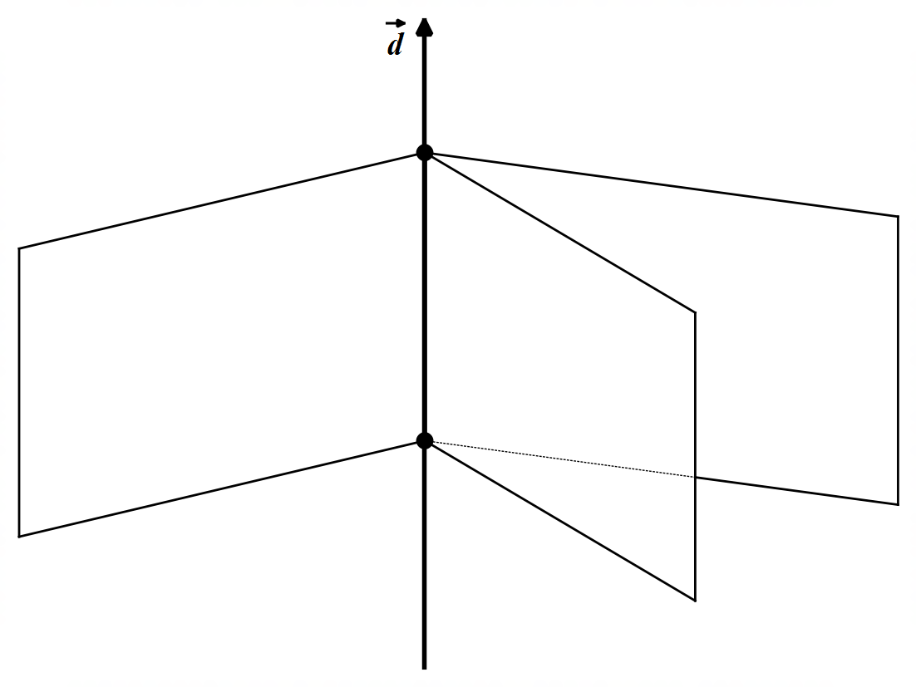

1. Find the vector equation of the line in the form of (4 marks)

Question 6 (12 marks)

The quadratic equation is given below, and its roots are labelled as and .

1. Find the roots of in the form of . (6 marks)

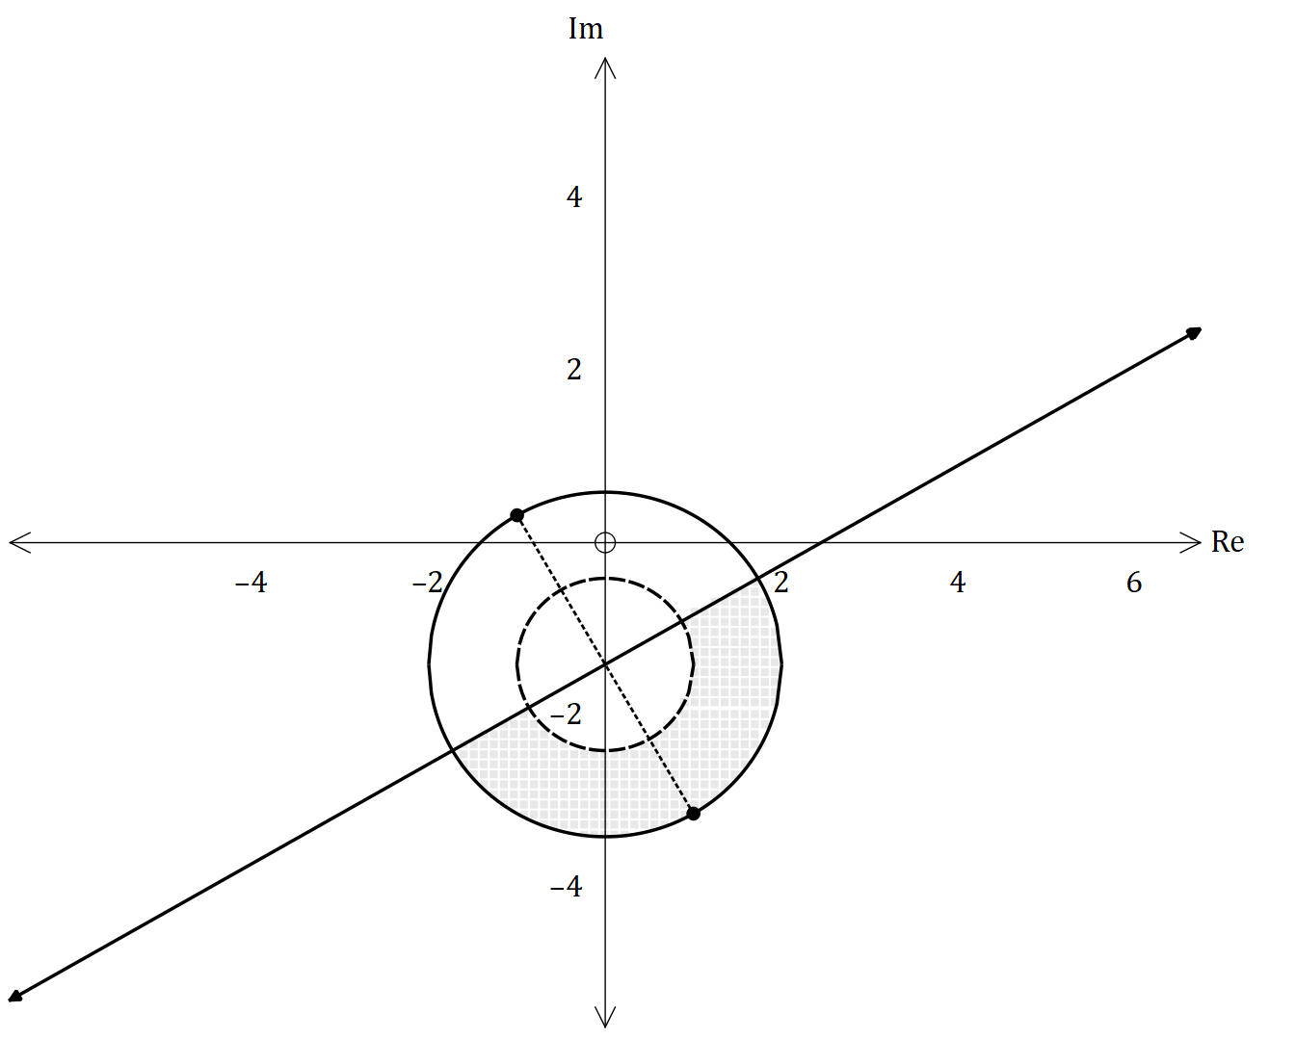

The roots and are plotted in an Argand diagram  
along with equations. One of them are defined   
as , where .

1. The vector loci expression is given below.   
   Find the values of the constants   
   and . (6 marks)
2. If and , find the value of the constants and (4 marks)
3. Plot and shade the loci in the above graph. (2 marks)

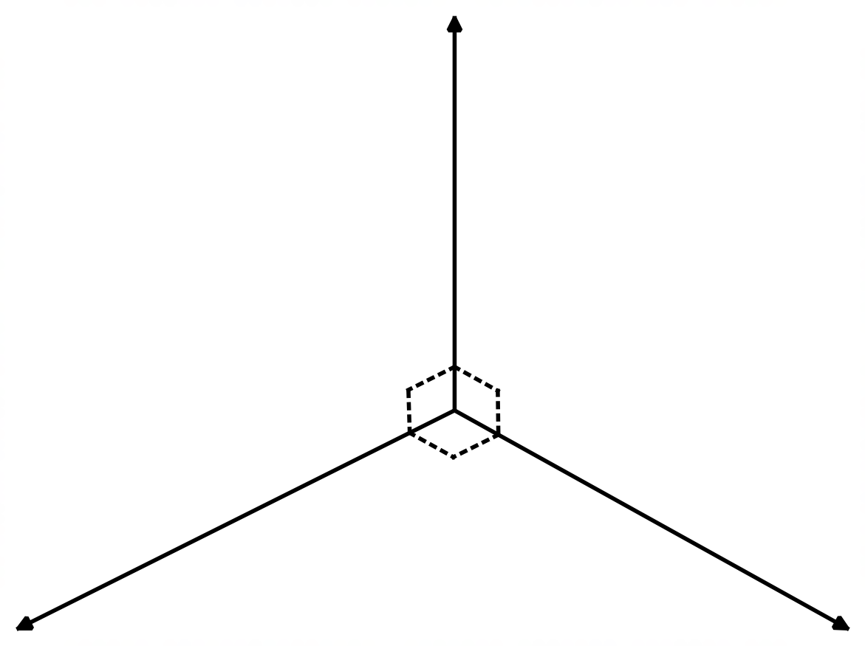Question 7 (9 marks)

1. By using the information to the right, if the  
   vector perpendicular to and is , find  
   . (5 marks)
2. The graph below shows the loci subset shaded and given. The point , is labelled and shown, with the coordinate . Hence, find the values of and if  
    and . (4 marks)

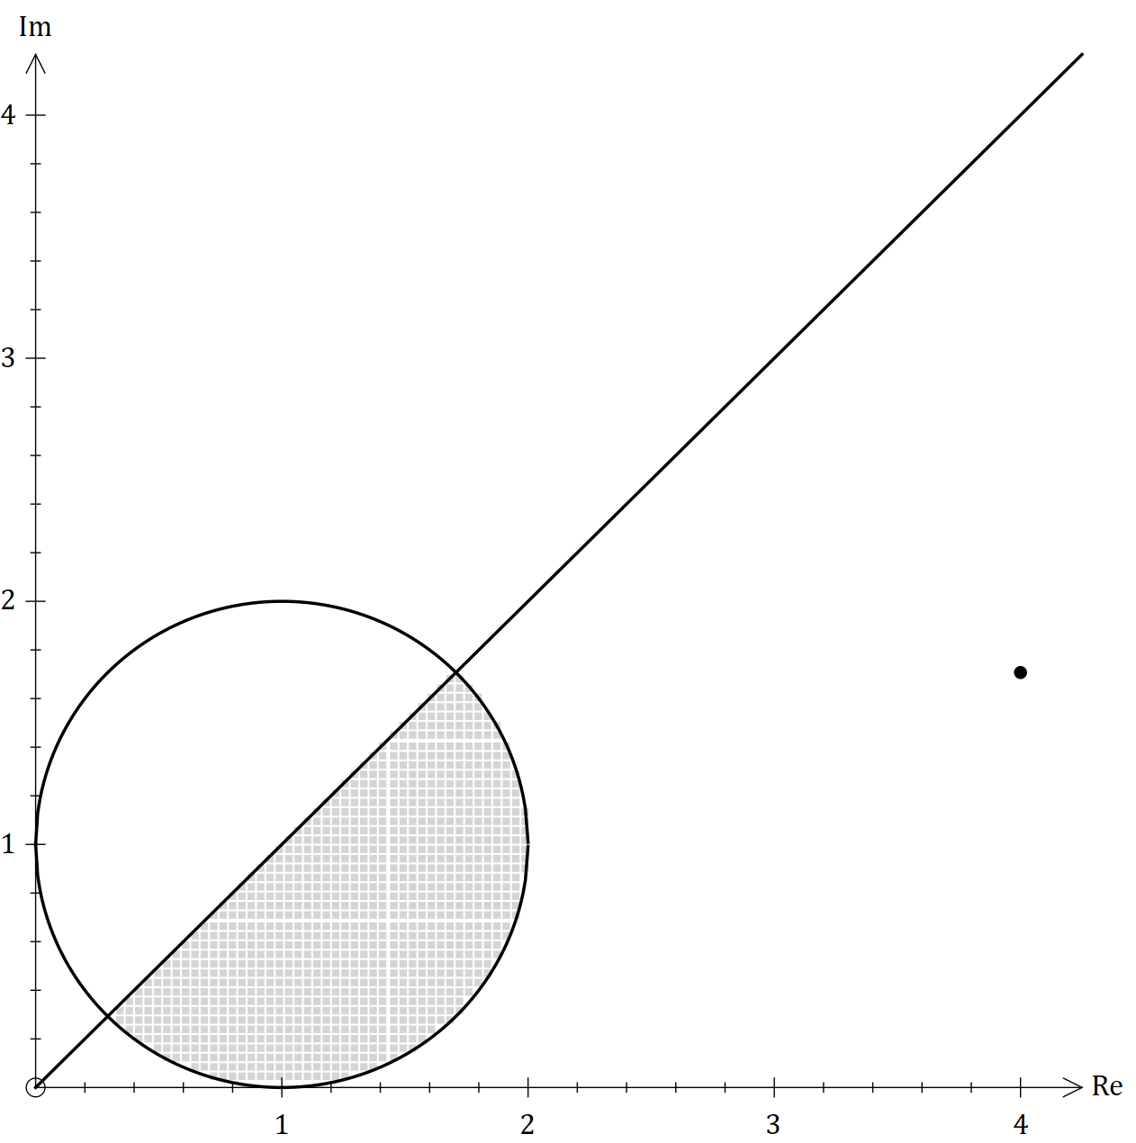

Question 8 (25 marks)

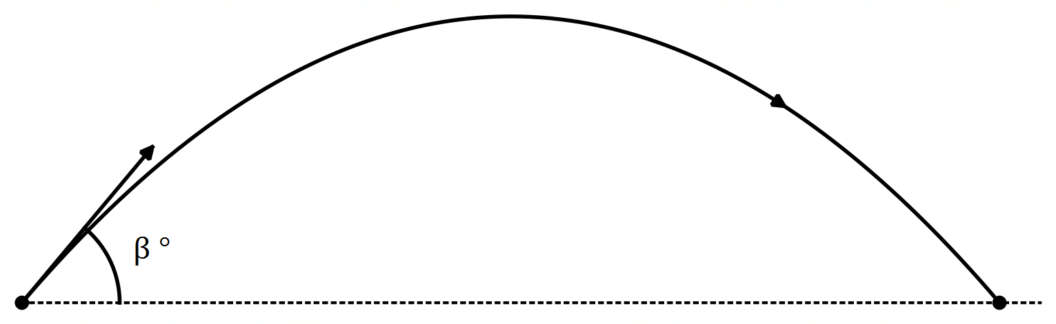

A man threw a ball with a mass of kg   
from ground level from the point .   
He threw it with a speed of ms-1 with   
an angle of elevation of , where the   
expression is true. The ball landed   
on the point , and lands on the same speed.

The only force acting on the ball is the acceleration due to gravity, which is approximately  
 ms-2. One of the observers uses their AM-9 to calculate the important information during its flight-time, like maximum height, distance travelled etc.

1. Find the magnitude of . (3 marks)
2. What is the speed of the ball when travelled to . (3 marks)

When the man hits the ball, the AM-9 must consider the principle for the conservation of energy, especially the thought of elastic collisions. Elastic collisions is when there is an encounter of two bodies, the total kinetic energy remains the same, thus meaning, no net conversion of any other forms of heat. This principle is shown below.

represents the speed in ms-1 and is the mass of the object in kg, where and represents the two bodies.  
The man at , uses a baseball bat with a mass of kg and before hitting the ball, had a speed of ms-1. After the collision, the speed of the bat was reduced by ms-1.

1. By using the expression and principles of perfect elastic collisions (shown below), find the speed of the ball when the baseball hits it. (2 marks)

The ball was now in circular motion, with a constant speed of ms-1 with a period of seconds.

The displacement of the ball m for seconds. This is further shown below.

1. Find the values of the constants and . (4 marks)

1. Prove that the ball is in circular motion, by justifying that . (3 marks)

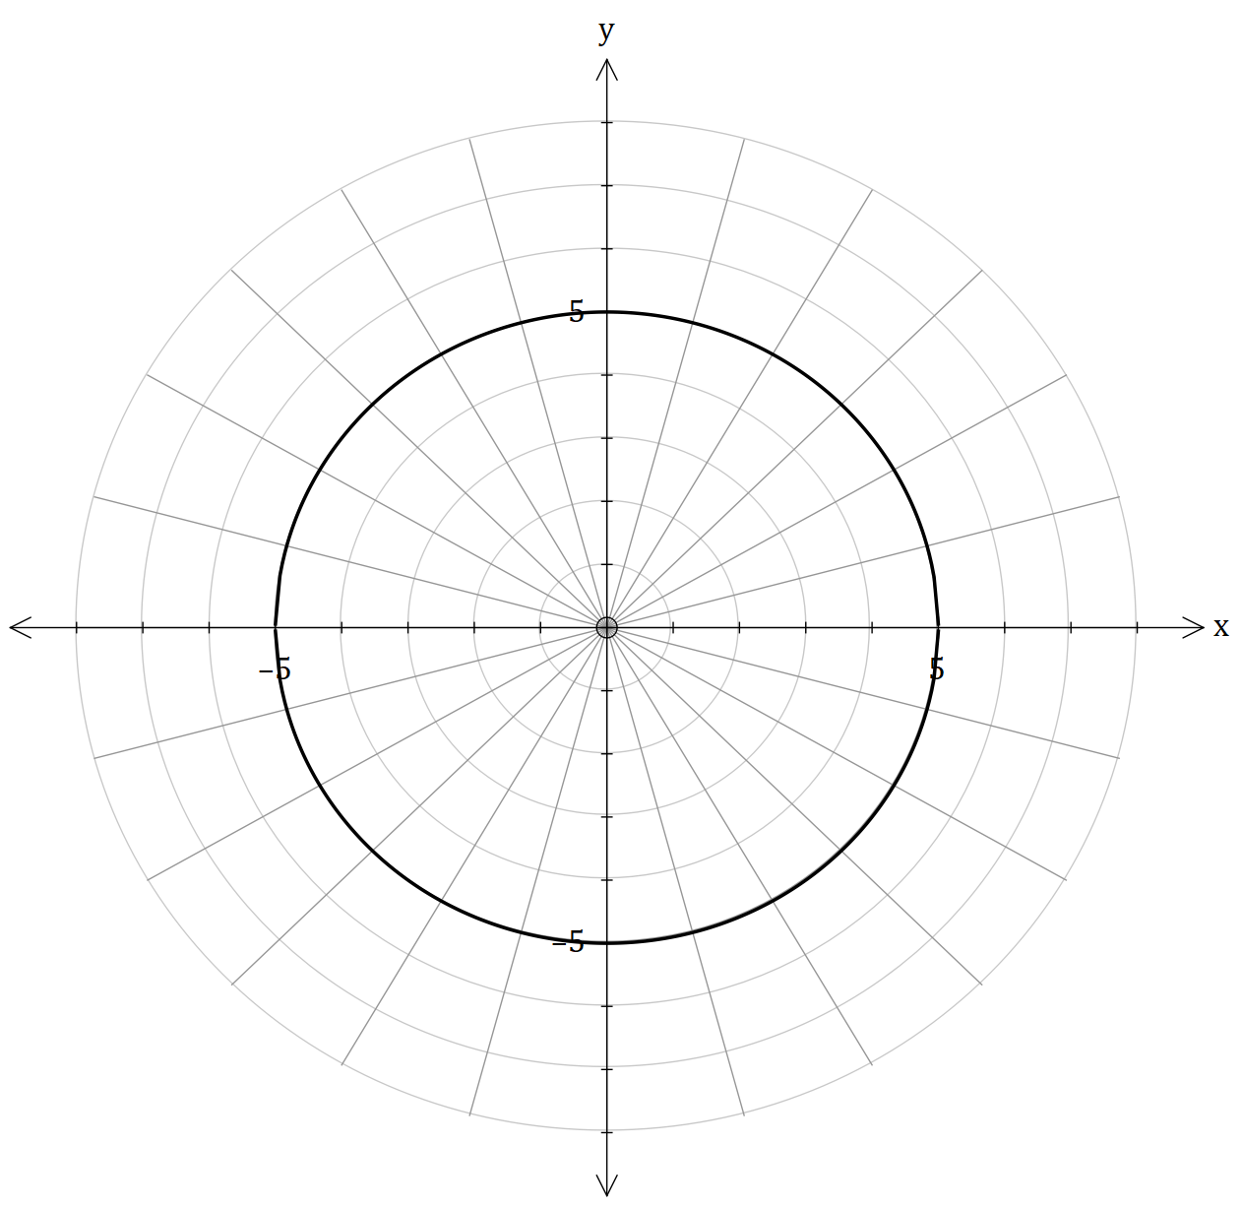Below shows the Cartesian equation of in a polar grid.

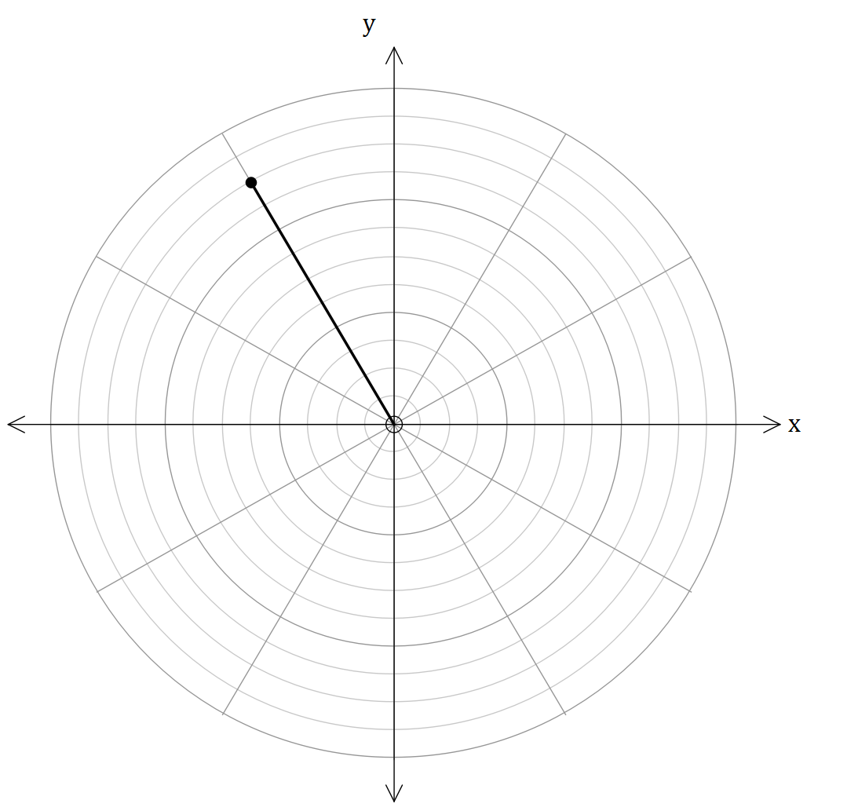While the ball is rotating in circular motion, a series of tennis balls with a mass kg, were rapidly shooting at the ball, attempting to hit the ball. It is then further discovered, the tennis balls   
struck kg ball, times. Each time the  
tennis balls struck it, the angular separation  
between them is , where is the number of   
strikes. However, AM-9 picked up only one of them.   
This is further discovered by the graph to the right.

1. If the ball was hit times, plot the other  
    strikes. (2 marks)
2. By using a complex equation shown   
   below, corresponds to the tennis strikes.

By finding and , find and   
plot the other strikes in the form   
of a vector format   
(4 marks)

It is further investigated that when the ball is struck by an even number of strikes, then the ball will stop moving. The observers dictate if the product of all roots of unity is , they can derive a breakthrough for the ball to stop moving.

1. Hence, consider the equation . Prove that the product of all roots of the equation is . (4 marks)

END OF CALCULATOR-FREE

Supplementary page

Question number: ___

Supplementary page

Question number: ___

Supplementary page

Question number: ___

Supplementary page

Question number: ___